ASSIGNMENT-4DISTANCEDETECTIONUSINGULTRASONICSENS

OR

|  |  |
| --- | --- |
| Date | 20October2022 |
| TeamID | PNT2022TMID41455 |
| Name | Nandhini.M |
| StudentRollNumber | 620619104017 |
| MaximumMarks | 2Marks |

Question1:Writecodeandconnectionsinwokwiforultrasonicsensor.Wheneverdistanceislessthan100cmssend"alert"toibmcloudanddisplayindevicerecentevents.

WOKWILINK:

https://wokwi.com/projects/305566932847821378

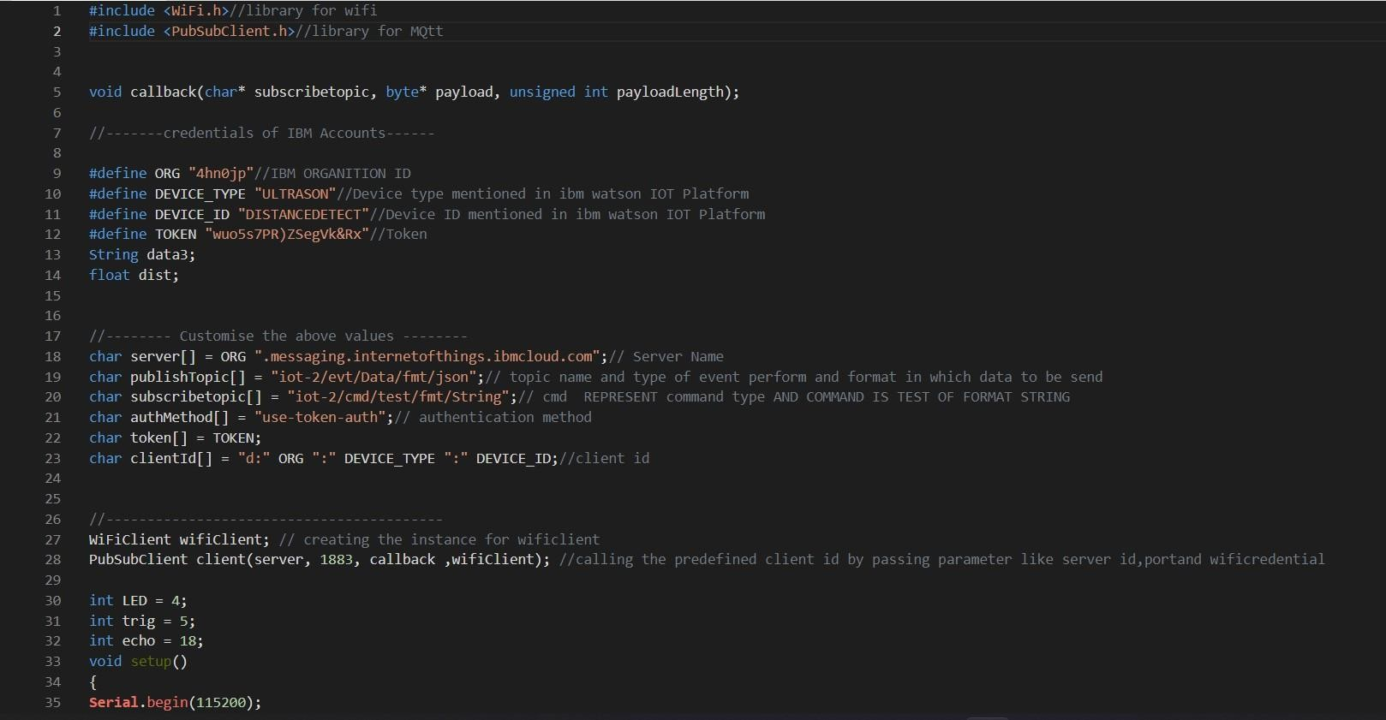CODE:

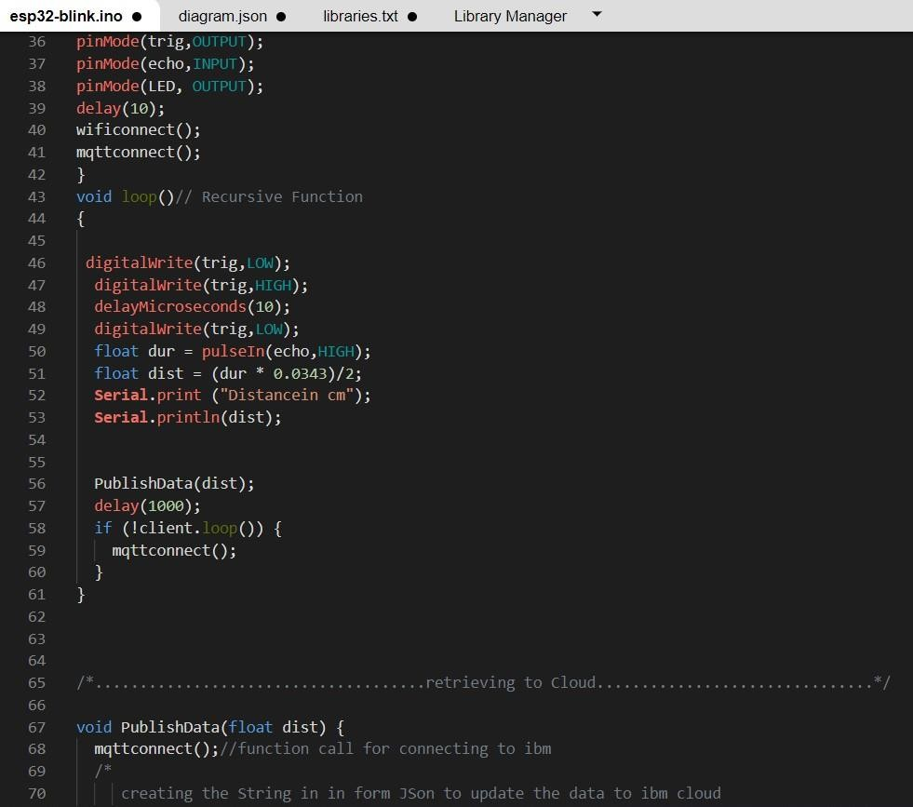

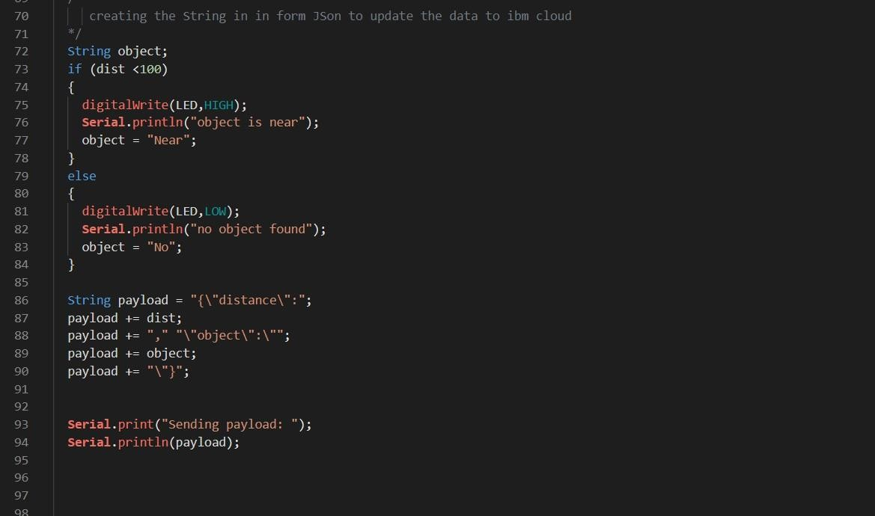

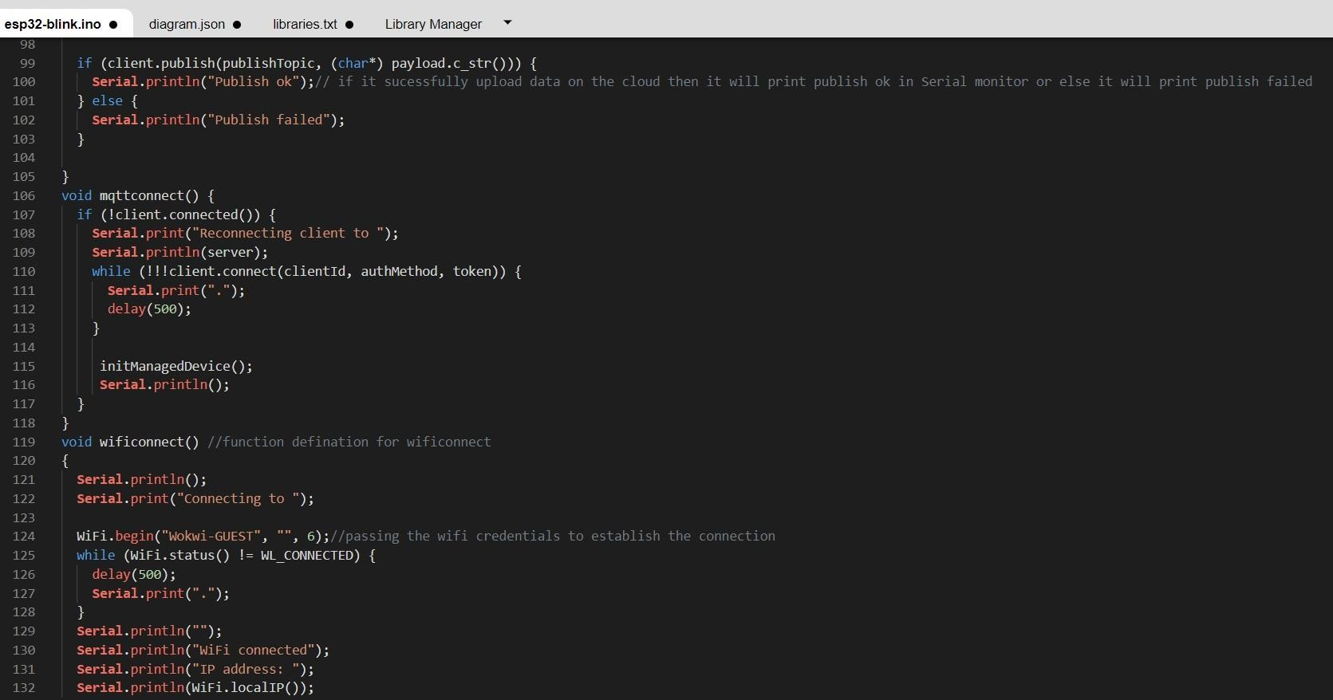

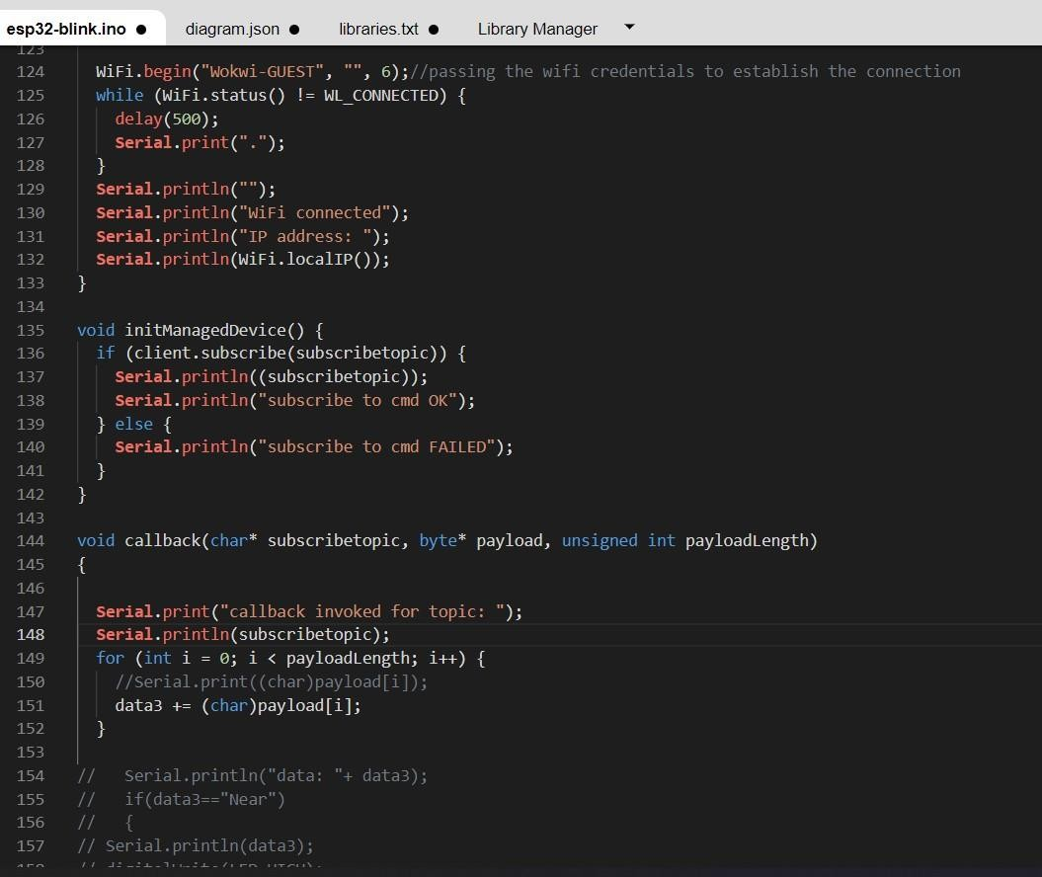

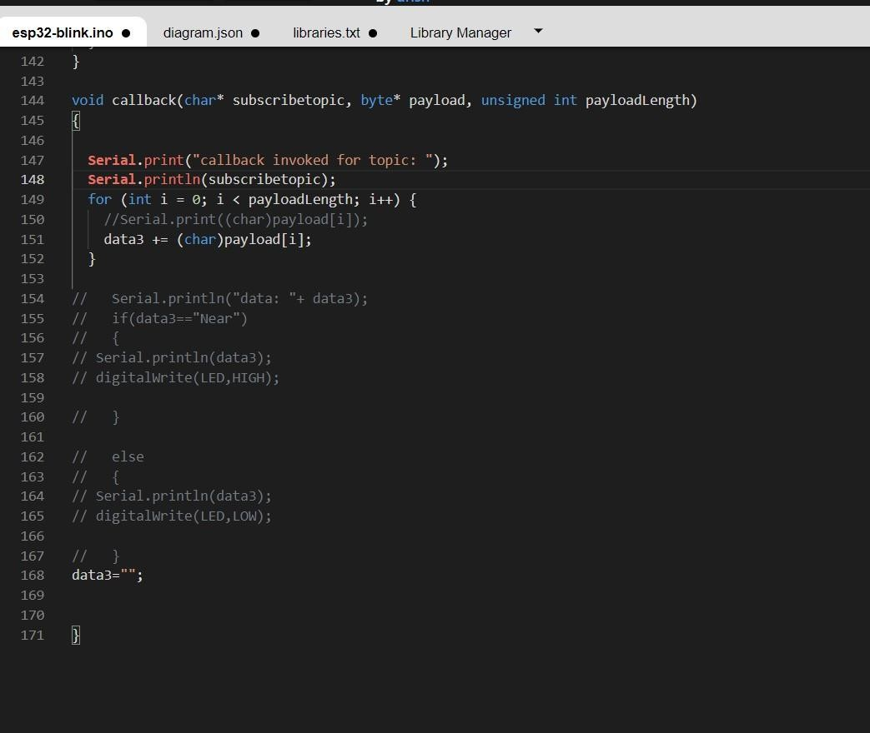

# OUTPUT:

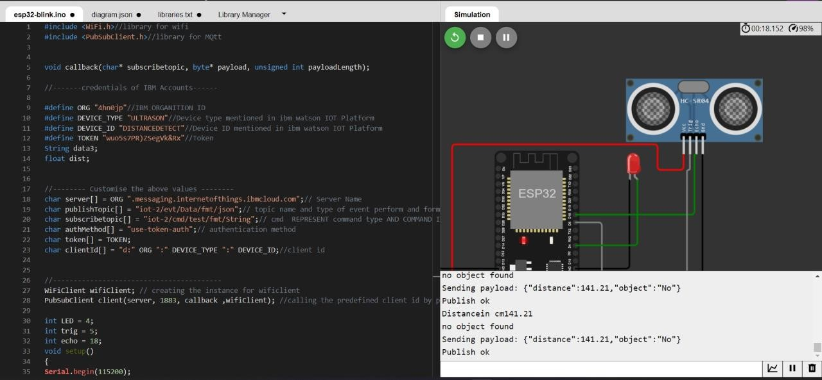

DatasendtotheIBMclouddevicewhentheobjectisfar

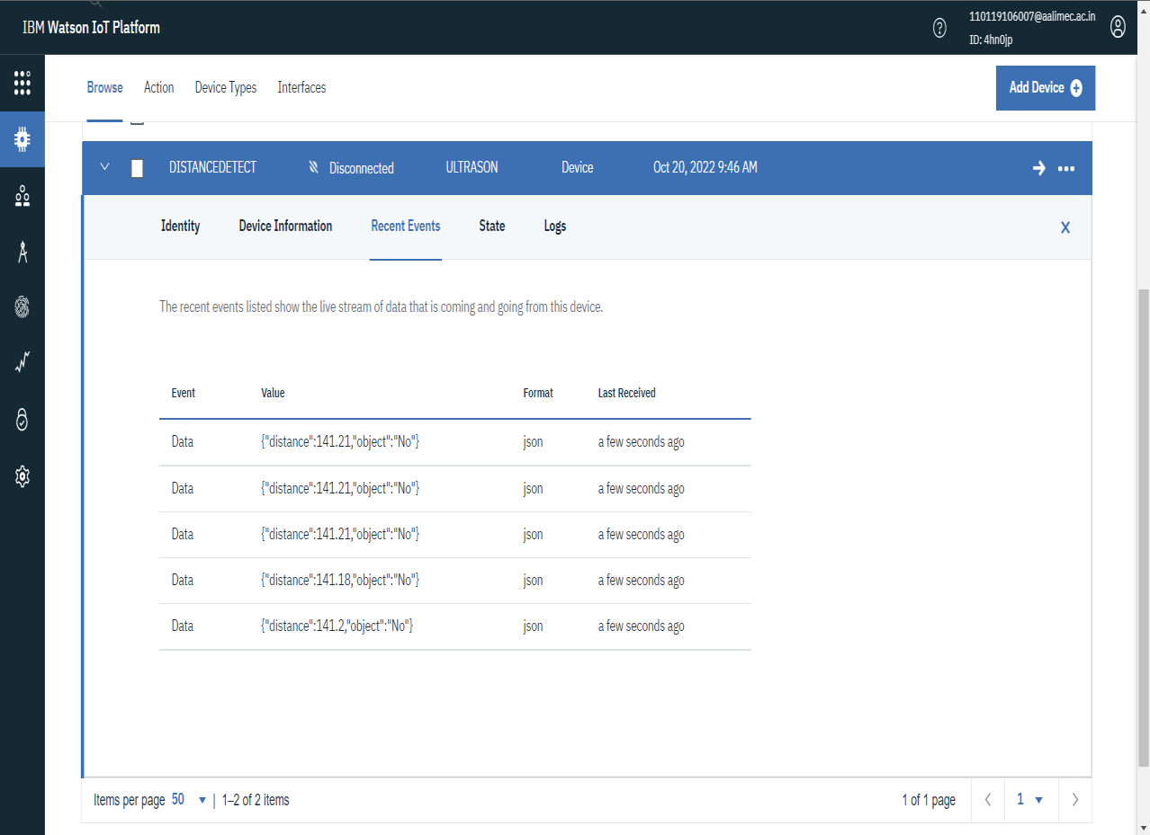

# whenobjectisneartotheultrasonicsensor

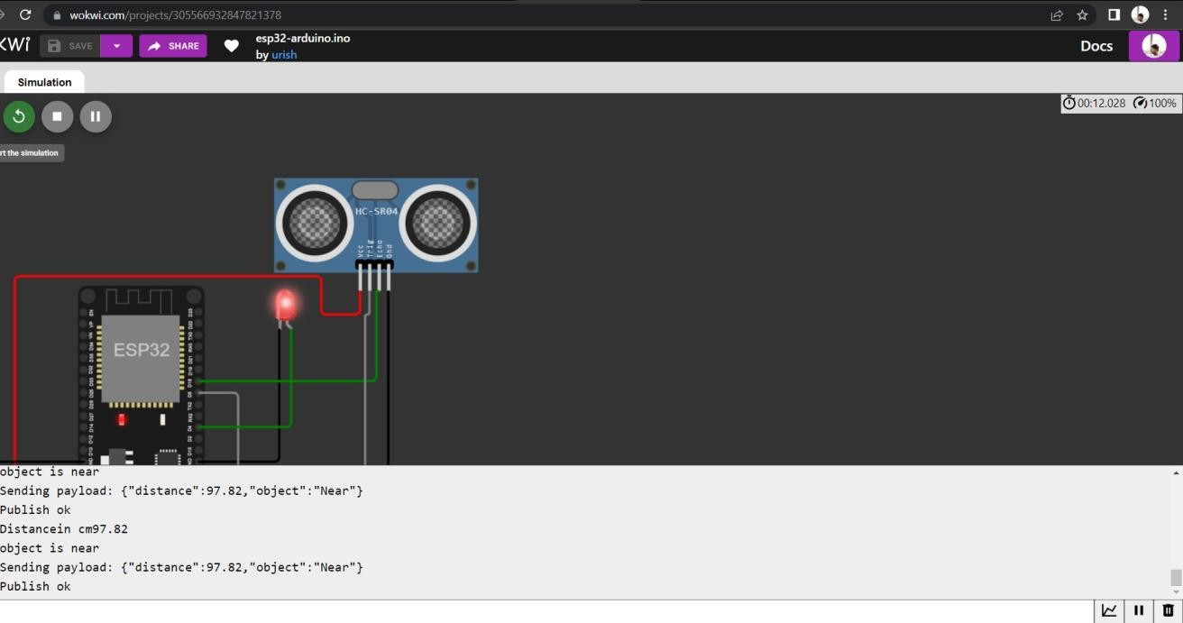

DatasenttotheIBMCloudDevicewhentheobjectisnear

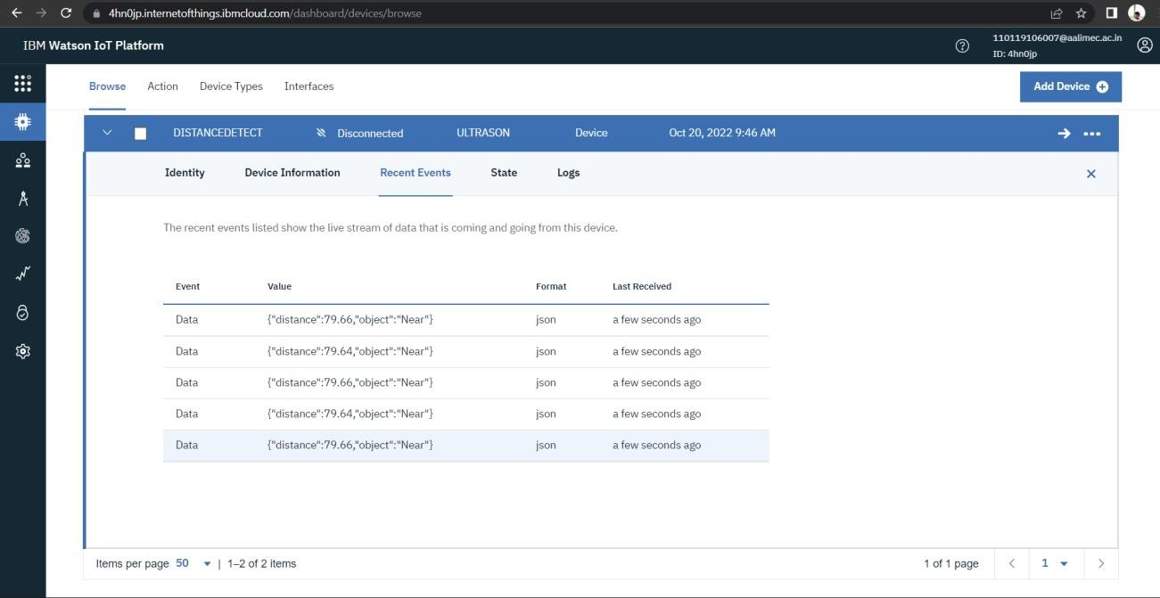

# https://wokwi.com/projects/305566932847821378